Student Performance Prediction System

Project Id: AIML-5

Name: Member1 (Stuti)
Class Roll Number: 69
University Roll Number: 2028866
Section and Group: P (g-2)

Name: Shaurya Mittal
Class Roll Number: 64
University Roll Number: 2028847
Section and Group: P(g-2)

Name: Tilak Singh
Class Roll Number: 73
University Roll Number: 2028883
Section and Group: P(g-2)

- Problem Description 3
- Architecture 4
- Models model 5
- Evaluation metrics used 6
- Preliminary Results and Visualizations 7
- References 8

- Problem Description
Urban water demand prediction is an important application in smart city management and sustainable resource planning. Increasing population, climate variations, and changing household consumption patterns have significantly increased pressure on urban water supply systems.
This project aims to predict household water demand using machine learning techniques based on demographic, environmental, and infrastructure-related features.
📌 Input Features
The dataset contains the following columns:
- Household Size
- Seasonal Index
- Garden Area
- Number of Bathrooms
- Children Count
- Elderly Count
- Appliance Count
- Temperature
🎯 Target Variable
- Urban Water Demand
📌 Objectives
- Analyse factors affecting water consumption.
- Predict future urban water demand.
- Compare machine learning algorithms.
- Improve efficient water resource management.

- Architecture
╔══════════════════════════════════════════════════════╗
║ 🌊 URBAN WATER DEMAND SYSTEM 🌊 ║
╚══════════════════════════════════════════════════════╝

┌─────────────────────────────┐
│ 📂 INPUT DATASET │
├─────────────────────────────┤
│ • Household Size │
│ • Seasonal Index │
│ • Garden Area │
│ • No. of Bathrooms │
│ • Children Count │
│ • Elderly Count │
│ • Appliance Count │
│ • Temperature │
└─────────────┬───────────────┘
│
▼

┌─────────────────────────────┐
│ 🧹 DATA PREPROCESSING │
├─────────────────────────────┤
│ • Missing Value Handling │
│ • Data Cleaning │
│ • Normalization │
│ • Feature Scaling │
└─────────────┬───────────────┘
│
▼

┌─────────────────────────────┐
│ ⚙ FEATURE ENGINEERING │
├─────────────────────────────┤
│ • Feature Selection │
│ • Correlation Analysis │
│ • Data Transformation │
└─────────────┬───────────────┘
│
▼

┌─────────────────────────────┐
│ 🤖 MACHINE LEARNING MODELS │
├─────────────────────────────┤
│ • Linear Regression │
│ • K-Means Clustering │
│ • Decision Tree │
└─────────────┬───────────────┘
│
▼

┌─────────────────────────────┐
│ 💧 PREDICTION MODULE │
├─────────────────────────────┤
│ • Predict Water Demand │
│ • Generate Forecasts │
└─────────────┬───────────────┘
│
▼

┌─────────────────────────────┐
│ 📊 PERFORMANCE ANALYSIS │
├─────────────────────────────┤
│ • MAE │
│ • RMSE │
│ • R² Score │
└─────────────────────────────┘

- Used (Applied/ Planned) Give a brief introduction of the models used

3.1 Linear Regression
Linear Regression is a supervised machine learning algorithm used for predicting continuous numerical values. It establishes a linear relationship between input variables and urban water demand.
Regression Equation
$$y=β_{0}+β_{1}x_{1}+β_{2}x_{2}+β_{3}x_{3}+β_{4}x_{4}+β_{5}x_{5}+β_{6}x_{6}+β_{7}x_{7}+β_{8}x_{8}$$
Advantages
- Simple and interpretable
- Fast training
- Good baseline model

3.2 K-Means Clustering
K-Means is an unsupervised machine learning algorithm used to group households with similar water consumption patterns.
Working Principle
$$J=\sum_{i=1}^{k}{\sum_{x_{j}∈C_{i}}{∣∣}}x_{j}-μ_{i}∣∣^{2}$$
Where:
- $C_{i}$= Cluster
- $μ_{i}$= Cluster centroid
Application
- Groups households into consumption categories
- Identifies high and low water usage patterns

3.3 Decision Tree
Decision Tree is a supervised learning algorithm that predicts water demand using hierarchical decision rules.
Features
- Handles nonlinear relationships
- Easy visualization
- Good interpretability
Application
Used for predicting water demand based on household and environmental conditions.

- Evaluation metrics used

4.1 Mean Absolute Error (MAE)
Measures average prediction error.
$$MAE=\frac{1}{n}\sum_{i=1}^{n}{∣}y_{i}-{\hat{y}}_{i}∣$$

4.2 Root Mean Squared Error (RMSE)
Measures square root of squared prediction errors.
$$RMSE=\sqrt{\frac{1}{n}\sum_{i=1}^{n}{(}y_{i}-{\hat{y}}_{i})^{2}}$$

4.3 R² Score
Measures how well the model explains data variance.
$$R^{2}=1-\frac{∑(y_{i}-{\hat{y}}_{i})^{2}}{∑(y_{i}-\overset{ˉ}{y})^{2}}$$

5. Preliminary Results and Visualizations

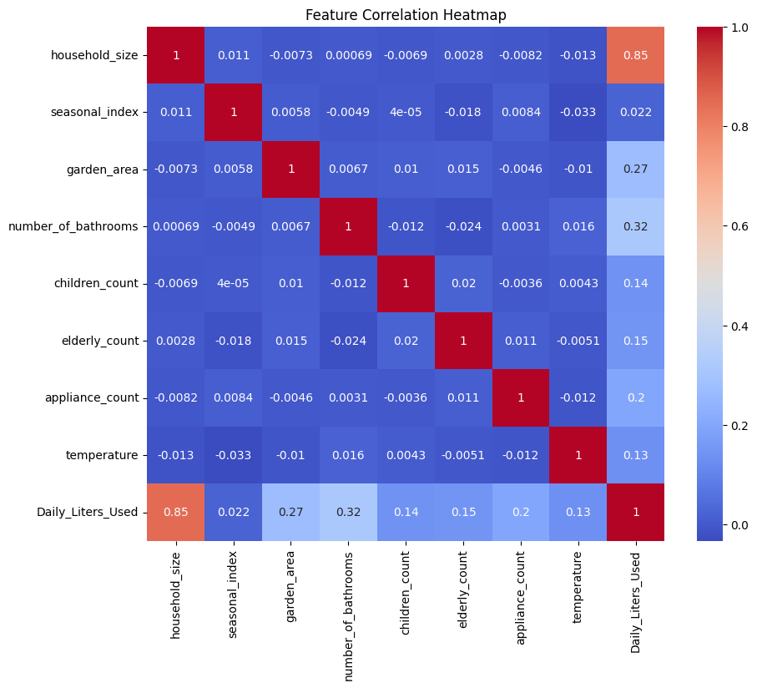

.
Linear Regression Best Fit Line

Water Demand
650 ┤ ●
620 ┤ ●
590 ┤
560 ┤ ●
530 ┤
500 ┤ ●
470 ┤
440 ┤ ●
410 ┤
380 ┤ ●
350 ┤ ●
320 ┤ ●
└───────────────────────────────────────────────▶
1 2 3 4 5 6 7 8
Household Features
─────────────────────
Best Fit Line

K-MEANS CLUSTERING

Water Usage
^
| ▲ ▲ ▲ ▲
| ▲ ▲ ▲ ▲ ▲ ▲
|
| ● ● ● ● ● ●
| ● ● ● ● ● ● ● ●
|
| ○ ○ ○ ○ ○ ○
| ○ ○ ○ ○ ○ ○ ○ ○
└────────────────────────────────────────▶
Household Categories

○ Cluster 1 → Low Water Usage
● Cluster 2 → Medium Water Usage
▲ Cluster 3 → High Water Usage

6. References:
• Hands-On Machine Learning with Scikit-Learn, Keras, and TensorFlow
• Pattern Recognition and Machine Learning
• Scikit-learn Documentation
• K-Means Clustering Documentation
• Decision Tree Documentation

